Introduction to Database Concepts

301242419 – Gasal, Carl Kevin

# **Question 1**

## Graphical user interface, text, application, email Description automatically generatedWhich customers live in New Jersey? List each customer’s last name, first name, and state.

## Graphical user interface, text, application Description automatically generated 2. Which orders shipped after April 1, 2009? List each order number and the date it shipped.

## Graphical user interface Description automatically generated 3. Which books aren’t in the Fitness category? List each book title and category.

4. Which customers live in Georgia or New Jersey? Put the results in ascending order by  
last name. List each customer’s customer number, last name, and state. Write this query  
in two different ways.

## Graphical user interface, application Description automatically generated 5. Which orders were placed on or before April 1, 2009? List each order number and order date. Write this query in two different ways.

6. List all authors whose last name contains the letter pattern “IN.” Put the results in order of last name, then first name. List each author’s last name and first name.

7. List all customers who were referred to the bookstore by another customer. List each  
customer’s last name and the number of the customer who made the referral.

8. Display the book title and category for all books in the Children and Cooking categories.  
Create three different queries to accomplish this task:  
*a) a search pattern operation,*  
*b)a logical operator, and*

*c)another operator not used in a or b.*

9. Use a search pattern to find any book title with “A” for the second letter and “N” for the fourth letter. List each book’s ISBN and title. Sort the list by title in descending order.

## 10. List the title and publish date of any computer book published in 2005. Perform the task of searching for the publish date by using three different methods: a) a range operator,

## b) a logical operator, “and”

## Graphical user interface, text, application, email Description automatically generated c) a search pattern operation.

# **Question 2**

To perform these assignments, refer to the tables in the JustLee Books database.

Generate and test two SQL queries for each of the following tasks: a) the SQL statement

needed to perform the stated task with the traditional approach, and b) the SQL statement

needed to perform the stated task with the JOIN keyword. Apply table aliases in all queries.

#### 1. Create a list that displays the title of each book and the name and phone number of the

#### Graphical user interface, text, application, email Description automatically generatedcontact at the publisher’s office for reordering each book.

#### 2. Determine which orders haven’t yet shipped and the name of the customer who placed the

#### order. Sort the results by the date on which the order was placed.

#### 3. Produce a list of all customers who live in the state of Florida and have ordered books

#### about computers.

#### 4. Determine which books customer Jake Lucas has purchased. Perform the search using the

#### customer name, not the customer number. If he has purchased multiple copies of the same

#### book, unduplicate the results.

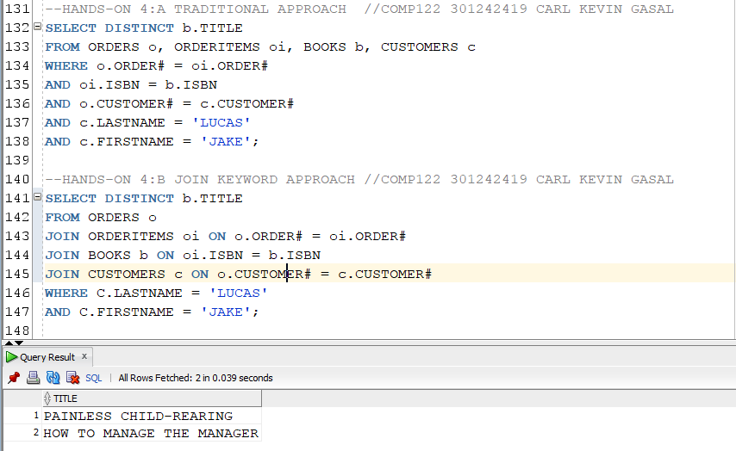

#### 5. Determine the profit of each book sold to Jake Lucas, using the actual price the customer

#### paid (not the book’s regular retail price). Sort the results by order date. If more than one

#### book was ordered, sort the results by profit amount in descending order. Perform the

#### search using the customer name, not the customer number.

#### 6. Which books were written by an author with the last name Adams? Perform the search

#### using the author name.

#### 7. What gift will a customer who orders the book Shortest Poems receive? Use the actual

#### book retail value to determine the gift.

#### 8. Identify the authors of the books Becca Nelson ordered. Perform the search using the

#### customer name.

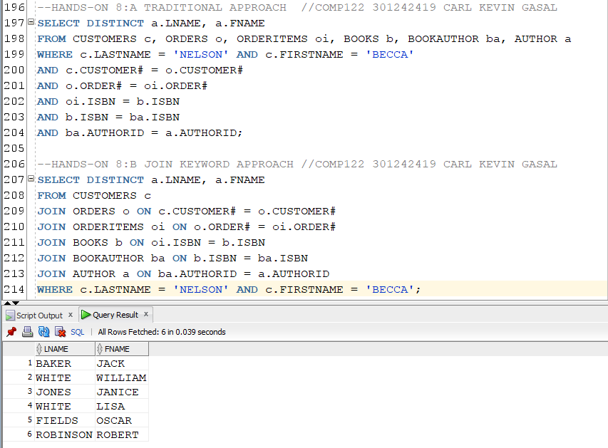

#### 9. Display a list of all books in the BOOKS table. If a book has been ordered by a customer,

#### also list the corresponding order number and the state in which the customer reside.

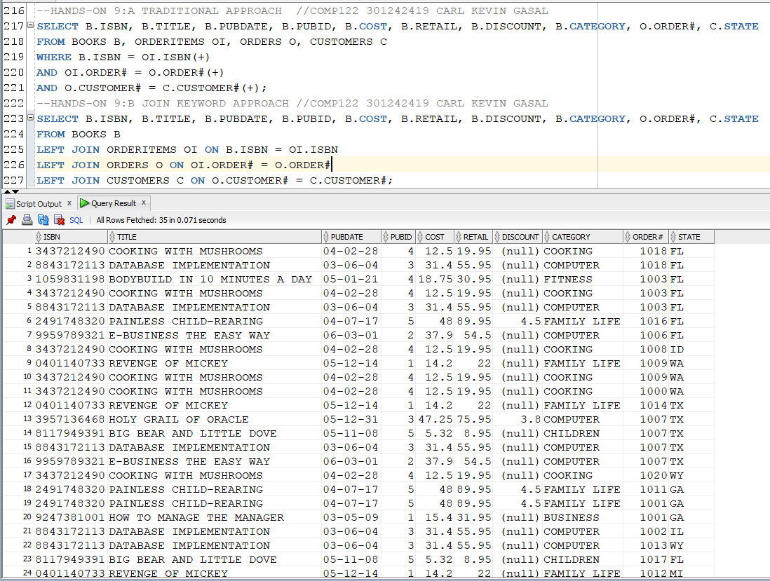

#### 10. An EMPLOYEES table was added to the JustLee Books database to track employee

#### information. Display a list of each employee’s name, job title, and manager’s name. Use

#### column aliases to clearly identify employee and manager name values. Include all

#### employees in the list and sort by manager name.

